Tableau Story Design

Date | 28 October 2026
Team ID | Not provided
Project Name | Global Fuel Prices and Taxation Trends (2020–2026)
Maximum Marks | 5 Marks

A Tableau story can guide viewers through the Global Fuel Prices and Taxation Trends dashboard in a logical sequence: begin with overall price trends, compare countries and regions, and then explore estimated tax and subsidy measures.
Suggested story sequence: (1) introduce the dataset and its limitations; (2) review fuel-price trends over time and by quarter; (3) compare countries and regions; (4) examine estimated tax-share patterns; (5) compare estimated tax and subsidy shares; and (6) close with interpretation cautions and possible next steps.

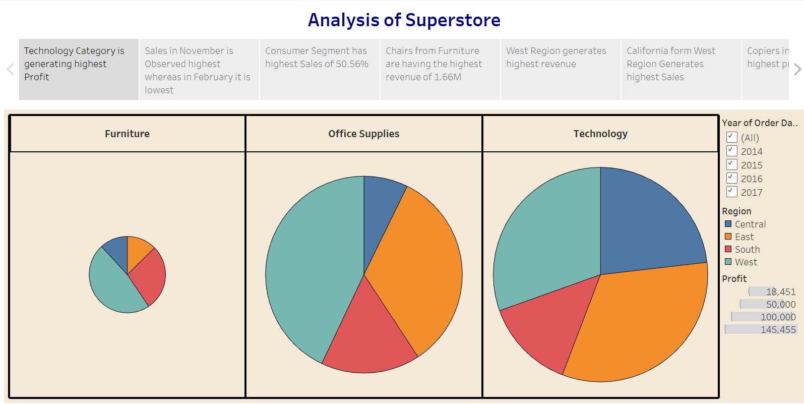

Suggested story points and observations to discuss
- Fuel-price trend view: Describe the pattern shown by the simulated data; do not generalize it to actual market history.
- Quarterly view: Compare quarters to demonstrate how a user might inspect within-year variation in the sample dataset.
- Country and regional comparisons: Use ranking and regional views to identify higher or lower entries in the displayed sample, noting that rankings are illustrative.
- Tax and subsidy views: Compare estimated tax-share and subsidy-share fields to demonstrate how fiscal measures could be explored together; do not infer real policy effects from simulated values.

Activity 2: Publish the completed Tableau story to Tableau Public if required and permitted. Paste the actual public URL below only after publication.
Tableau Public link: [Add your published Tableau Story URL here]
https://public.tableau.com/views/SalesStory_17247663658720/Story1?:language=en-US&:sid=&:redirect=auth&:display_count=n&:origin=viz_share_linkData disclaimer: The dataset values are simulated demonstration data and are not verified real-world statistics.

